|  |
| --- |
| Søren Andersen og Mikkel Anton Andersen tagged you in the hike, From Brede to Lillerød |
|  |
| |  | | --- | |  | | |  |  |  |  |  | | --- | --- | --- | --- | --- | |  | | | | | |  | https://static.komoot.de/email/transactional/badges/badge-tour-hike.png |  | **From Brede to Lillerød** |  | |  | | | | | | | |  |  |  | | --- | --- | --- | |  | | | |  | |  |  |  |  |  |  |  |  |  |  |  |  |  |  |  | | --- | --- | --- | --- | --- | --- | --- | --- | --- | --- | --- | --- | --- | --- | --- | | |  | | --- | | https://static.komoot.de/email/transactional/tour/icon-duration.png | | **2:25** | | |  | | --- | | https://static.komoot.de/email/transactional/tour/icon-distance.png | | **13.3 km** | | |  | | --- | | https://static.komoot.de/email/transactional/tour/icon-uphill.png | | **50 m** | | |  | | --- | | https://static.komoot.de/email/transactional/tour/icon-downhill.png | | **60 m** | | |  | | --- | | https://static.komoot.de/email/transactional/tour/icon-speed.png | | **5 km/h** | | |  | |  | | | | |

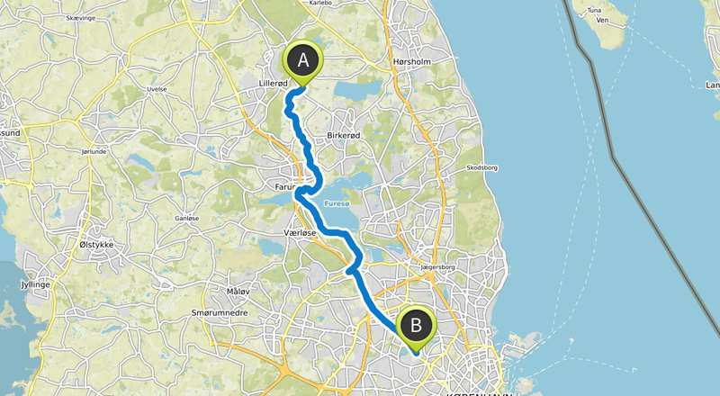

|  |
| --- |
| Søren tagged you in the hike, Far og søn tour |
|  |
| |  | | --- | | Far og søn tour | | |  |  |  |  |  | | --- | --- | --- | --- | --- | |  | | | | | |  | https://static.komoot.de/email/transactional/badges/badge-tour-hike.png |  | **Far og søn tour** |  | |  | | | | | | | |  |  |  | | --- | --- | --- | |  | | | |  | |  |  |  |  |  |  |  |  |  |  |  |  |  |  |  | | --- | --- | --- | --- | --- | --- | --- | --- | --- | --- | --- | --- | --- | --- | --- | | |  | | --- | | https://static.komoot.de/email/transactional/tour/icon-duration.png | | **4:40** | | |  | | --- | | https://static.komoot.de/email/transactional/tour/icon-distance.png | | **23.9 km** | | |  | | --- | | https://static.komoot.de/email/transactional/tour/icon-uphill.png | | **190 m** | | |  | | --- | | https://static.komoot.de/email/transactional/tour/icon-downhill.png | | **160 m** | | |  | | --- | | https://static.komoot.de/email/transactional/tour/icon-speed.png | | **5 km/h** | | |  | |  | | | | |
|  |
| Søren tagged you in the hike, From Utterslev to Lillerød |
|  |
| |  | | --- | | From Utterslev to Lillerød | | |  |  |  |  |  | | --- | --- | --- | --- | --- | |  | | | | | |  | https://static.komoot.de/email/transactional/badges/badge-tour-hike.png |  | **From Utterslev to Lillerød** |  | |  | | | | | | | |  |  |  | | --- | --- | --- | |  | | | |  | |  |  |  |  |  |  |  |  |  |  |  |  |  |  |  | | --- | --- | --- | --- | --- | --- | --- | --- | --- | --- | --- | --- | --- | --- | --- | | |  | | --- | | https://static.komoot.de/email/transactional/tour/icon-duration.png | | **3:46** | | |  | | --- | | https://static.komoot.de/email/transactional/tour/icon-distance.png | | **27.6 km** | | |  | | --- | | https://static.komoot.de/email/transactional/tour/icon-uphill.png | | **140 m** | | |  | | --- | | https://static.komoot.de/email/transactional/tour/icon-downhill.png | | **170 m** | | |  | | --- | | https://static.komoot.de/email/transactional/tour/icon-speed.png | | **7 km/h** | | |  | |  | | | | |